Book launch
18th April 2015

The Player’s View
Menaggio & Cadenabbia Golf Club
a round of golf on your coffee table



[This page has deliberately been left blank, to facilitate double-sided printing.]
Commander John Harris’s 4th at Menaggio GC on 16th April, 2015 – a spring celebration of its 50th anniversary Low resolution image © The Hynes Collection, 2015

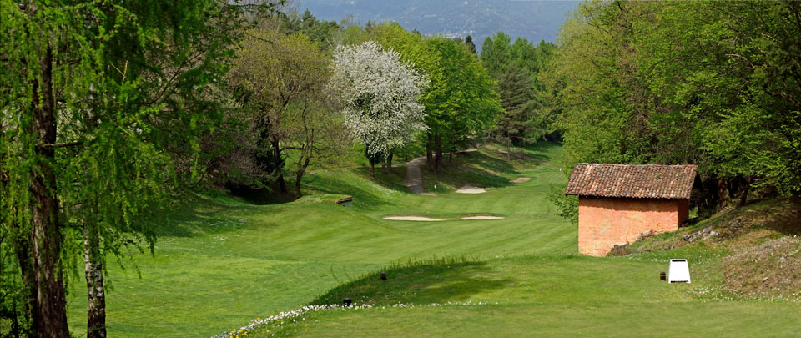
Release
The launch

The Player’s View: Menaggio & Cadenabbia Golf Club, the second in Beckenham’s new series of coffee table books, was launched at the club on Saturday 18th April. The first book in the series (also recently published) covers St George’s Hill GC, near London. The presentation of the Menaggio volume was preceded by The Player’s View Cup golf tournament, won by:
Gross Stableford points Negri Guido 30
Net (Division 1) Gaia Spreafico 37
Net (Division 2) Massimo Formenti 43
Net (Division 3) Alan Crosta 42

The launch was introduced to club members by President Vittorio Roncoroni, and presented by author William fforde. The presence of special guests Ted Dexter and Oliver Harris made this an historic event. As a former club-owning Dexter, Ted spent his childhood holidays at Menaggio and helped his father restore the golf course after WW2. In the 1960s, it was extended to the design of Cdr John Harris, Oliver’s high-living and well-travelled father, reputed as ‘the James Bond of golf course design’. The third special guest was sculptor Stefano Ughi (a longstanding friend of the author), to whom the book is dedicated, and whose childhood neighbour was Sir James Henderson, another former owner of the club (and founder of a famous school in Milan).

The presentation was preceded by the première screening of a short film, which promotes the concept of The Player’s View book series. The books comprise:
- a promotional tool for club owners and promoters – a unique feature is that each hole is presented visually, shot by shot;
- a seductive memento for club members and visitors alike;
- a must for golf collectors, as they are signed, limited edition photobooks.
[Permanently embargoed: The film (soon to be published on our website) may be seen at vimeo.com/125553603. Password: menaggio]

The special guests and William fforde, respectively, presented photos and a copy of St George’s Hill GC’s centenary history to the club. In addition, all those present were given a complimentary copy of The Pocket Guide to Golf Courses: Ireland, also written by fforde.

The Player’s View: Menaggio & Cadenabbia GC

Stunning, double-page-spread photography takes us on a full round of the Menaggio course from tee to green, shot by shot from the 1st tee to 18th green. The images form part of the newly-inaugurated Hynes Collection at the University of St Andrews.

In the engaging text, fforde takes us to God’s clubhouse in the sky to review the course with J H Taylor and John Harris (its designers), in the company of the ever-loquacious San Bernardo (aka Bernard Darwin), amidst biblical misquotes. He also refuses to identify one of the more famous members of the club, a recently-remarried American film star. Hidden within the text are 26 of his film titles.

The story of how former English cricket captain, Ted Dexter’s father saw to the course’s restoration after WW2 is presented as extracts from ‘The Book of Ralph’. This anachronism, a hitherto lost book of The Holy Bible, in which even Mussolini scores a footnote, seems to have been phished from heaven following a lapse in St Andrew’s security systems.

/Quotes follow overleaf…
Quotes

Commenting on this new series, Vittorio Roncoroni, President of Menaggio & Cadenabbia GC, said:

“When William told me what he wanted to do, I thought it was a great idea. It was something that Menaggio didn’t have and it makes a great promotional tool.

We have a world-renowned library, and are delighted to have commissioned one of the two pilot volumes for this new and exciting way to show off a golf course, supported by photos and research associated with the University of St Andrews.

The fact that the books are signed limited editions is also highly appropriate, and will make this series of interest to collectors as well as visitors and members.”

William fforde, author (also Beckenham’s Editor) said:

“The unique feature of these books is that, page by page, you can imagine yourself playing each hole in order, shot by shot.

With the photos, I compose each shot to give us the feeling that we are actually there, club in hand – hence the title “The Player’s View”. And with the text, I have had the fun of balancing research into the history of each hole’s design, with tongue in cheek moments, biblical anachronisms, deliberate misquotes and hidden references to the club’s most famous member.

The people who read these books will more fully understand the philosophy of the designer, and why things are as they are on a golf course. This will help them think their way around the course perhaps in a slightly different, possibly more strategic, way than they have done in the past, and so ultimately enrich their golfing experience.”

Former England cricket captain, Ted Dexter (who wrote the Foreword), said:

“This place was home to me in the late 1940s, and it is where, encouraged by Maestro Prete, my brother John and I learned to play golf. In later years John established a “village” cricket ground nearby. Cricket must have been in our blood.
I have been in love with Menaggio ever since. So I was delighted to tell William about my dear father’s and brother’s roles in the history of the golf course: to then see it all encapsulated within his imagination of a hitherto lost and rather anachronistic book from the Bible was intriguing, to say the least. And it was a pleasure to add my personal feelings in the Foreword.
A month short of my 80th birthday party (which my entire family have decided without question should be held here), I look forward to returning shortly and playing in this year’s celebratory edition of La Coppa Dexter.”

Oliver Harris (son of Cdr John Harris, who redesigned the course in 1965), said:

“A recent visit to my father’s course at Wairakei, New Zealand (rated as one of his best), truly whetted my appetite to see and play more of his courses (most of which are outside the UK). Whether or not he lived up to the ‘James Bond standards’ (with which he was once labelled), we will never know. From reading William’s book, it seems the local Secret Service agent was in fact Sir James Henderson.
What we do know is that my father was a friend of Antonio Roncoroni (Vittorio’s uncle), and that the proximity of Villa d’Este, his favourite hotel, was an added attraction. These ingredients, plus the amazing local scenery, inspired him to create the wonderful course that I have just played so badly: ‘Dad, today you win! But tomorrow…’.
My pre-launch copy of the book made me want to play here: seductive indeed. And the amazing British-style clubhouse, its library, accommodation and wonderful food (nothing British about that!) blew us away. Now, I want to go see my father’s other Italian courses: Olgiata, here we come!”

/Photos follow overleaf…
Photos

Images from the launch – high resolution versions of all the images below are available on DropBox – please email william@players-view.com for an invitation to the link.

The Player’s View Cup & Winners
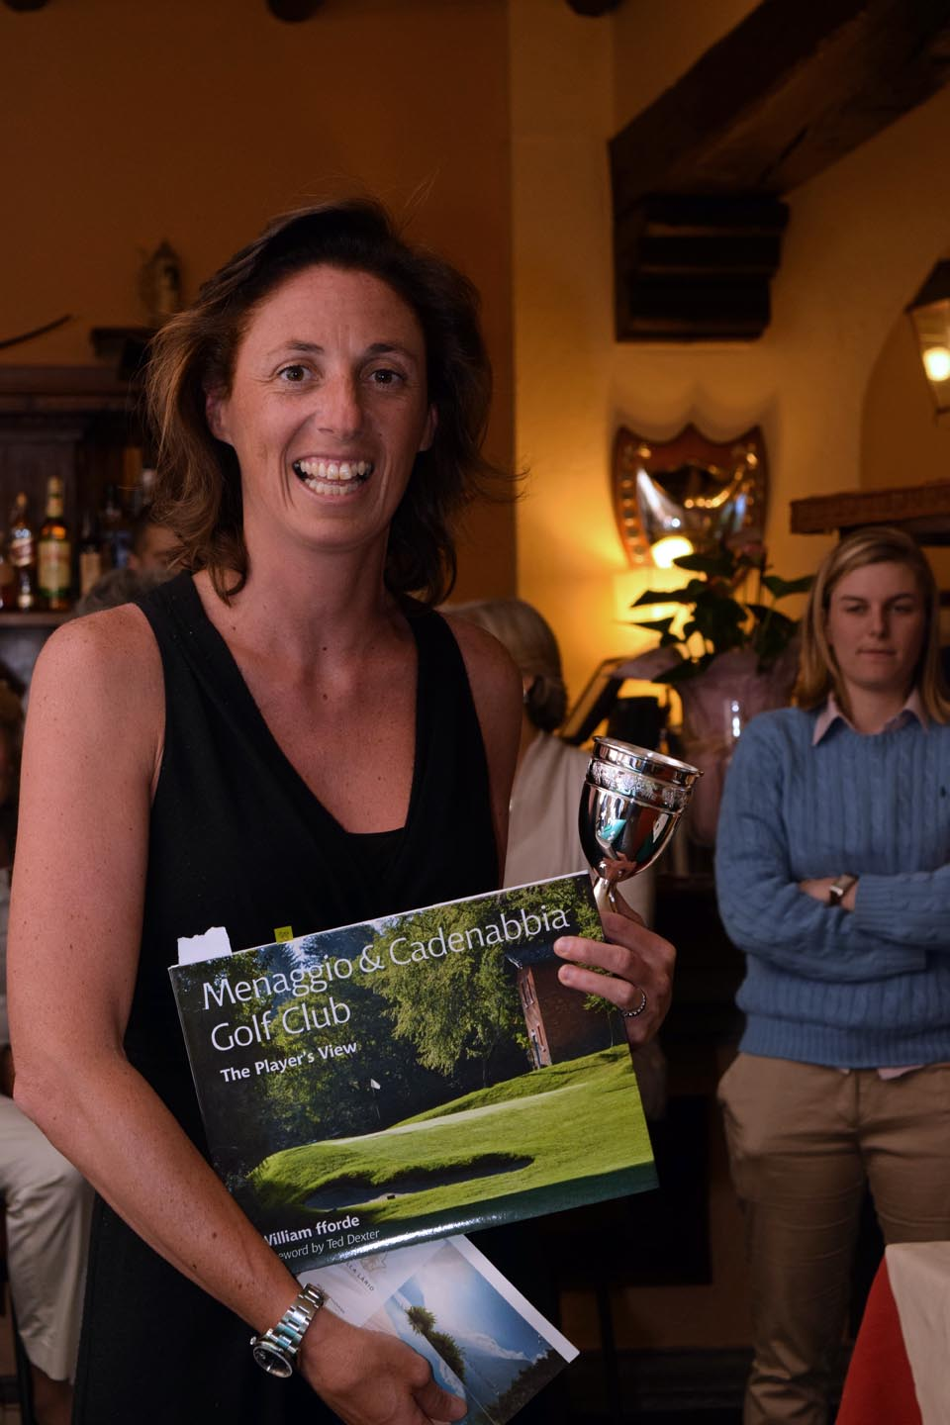

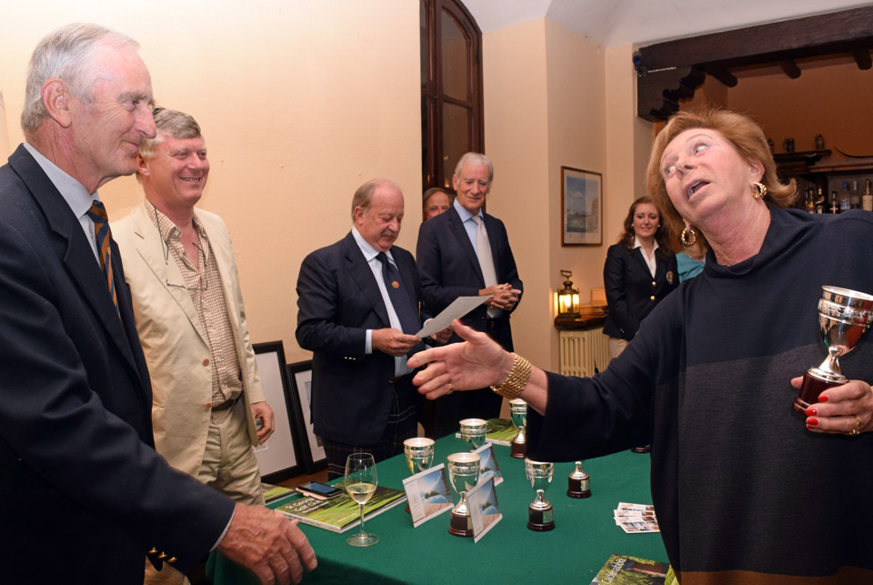
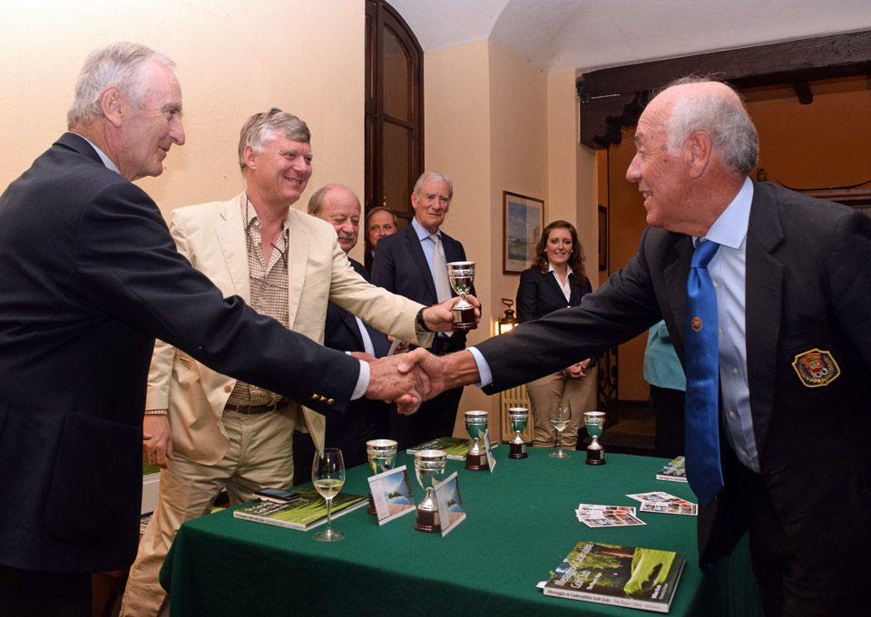
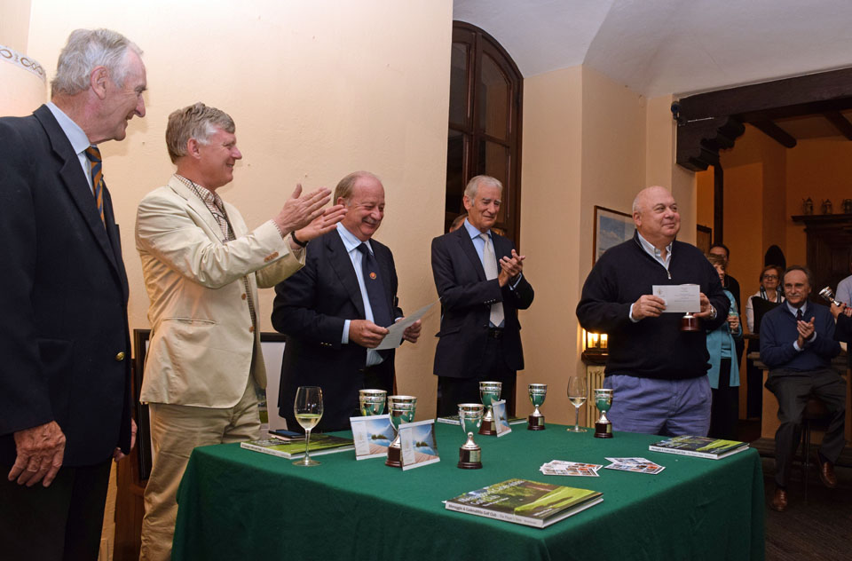

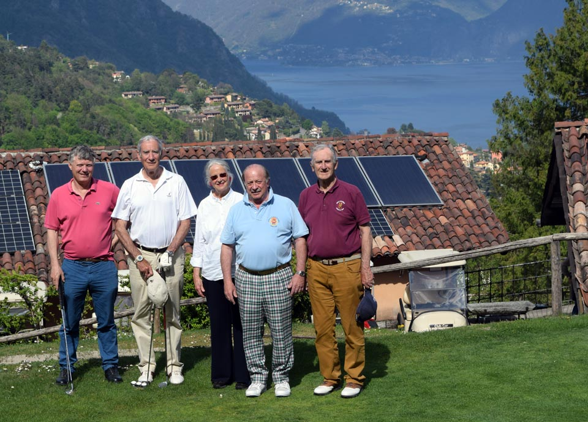

Presentation of the Book
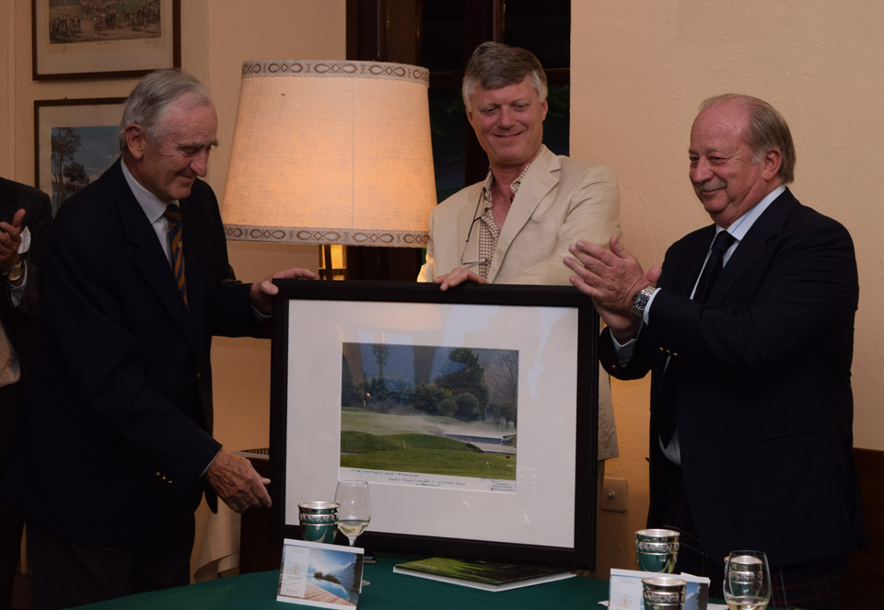
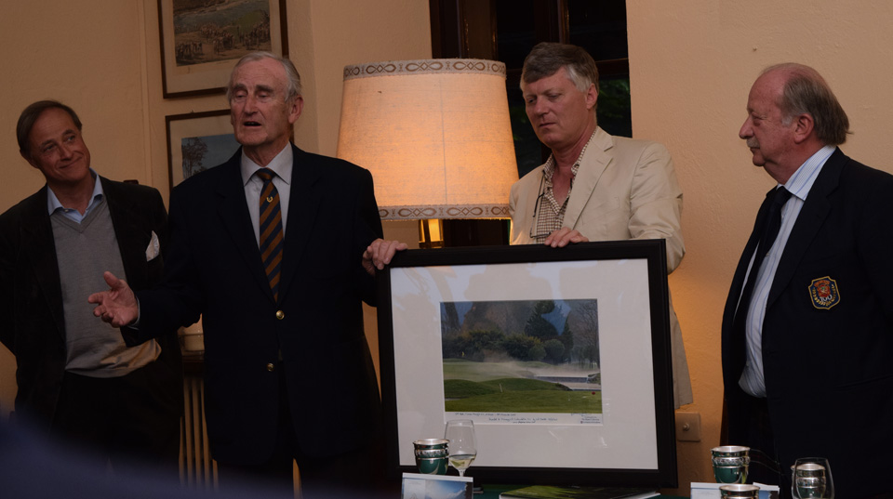
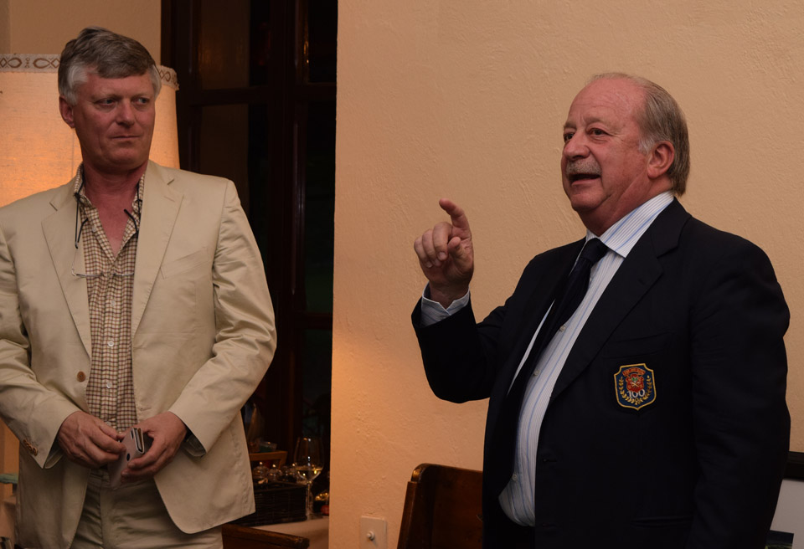
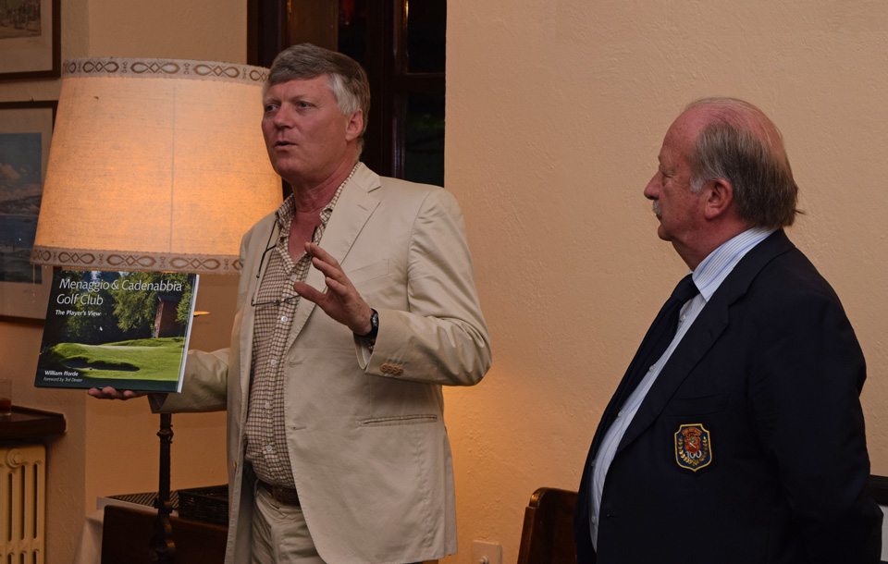

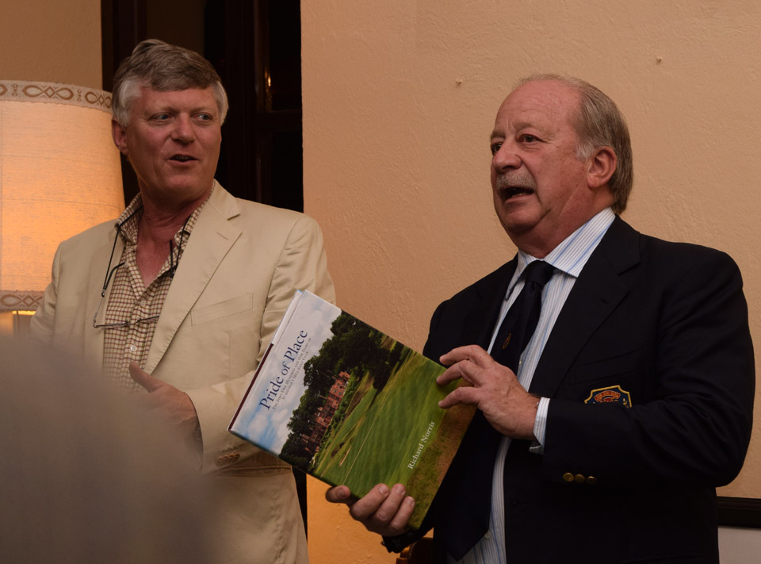
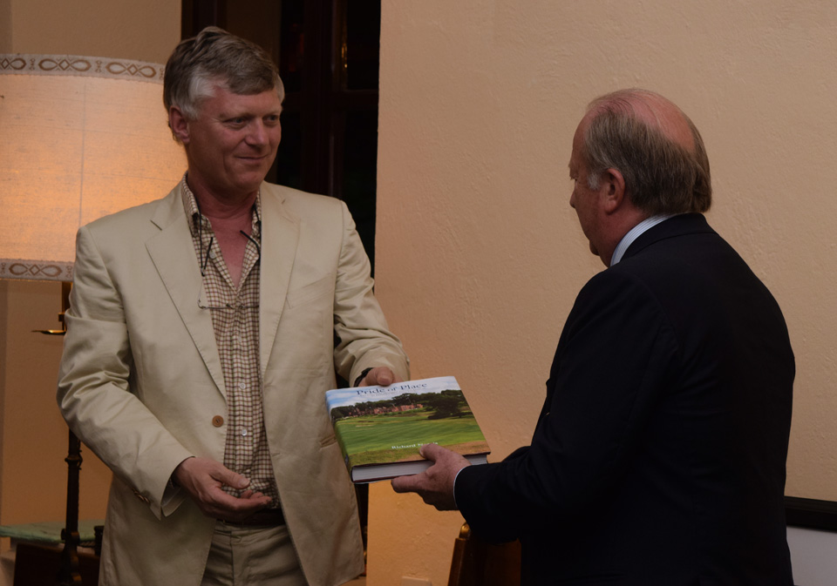
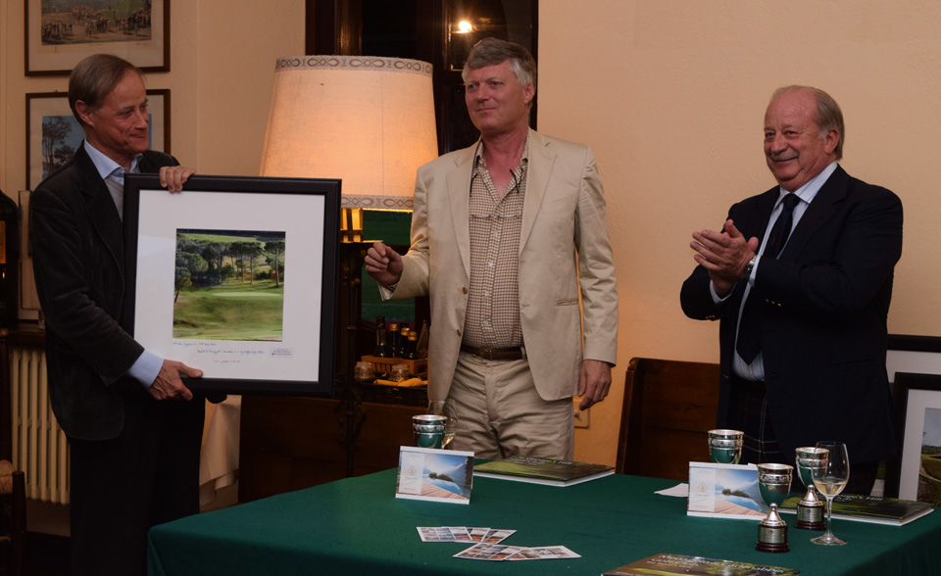
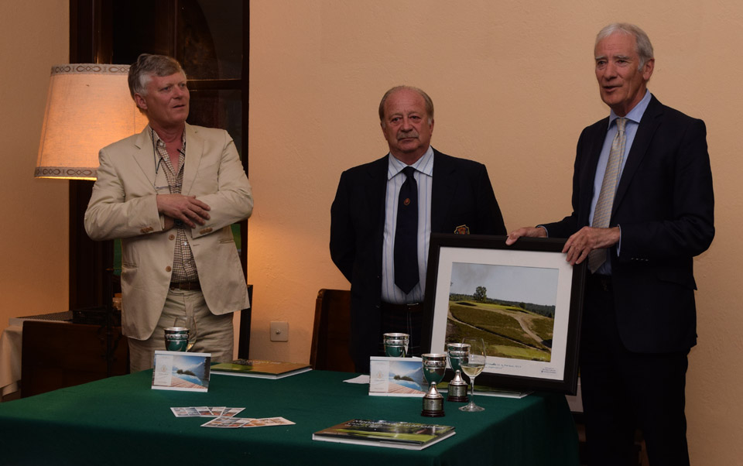

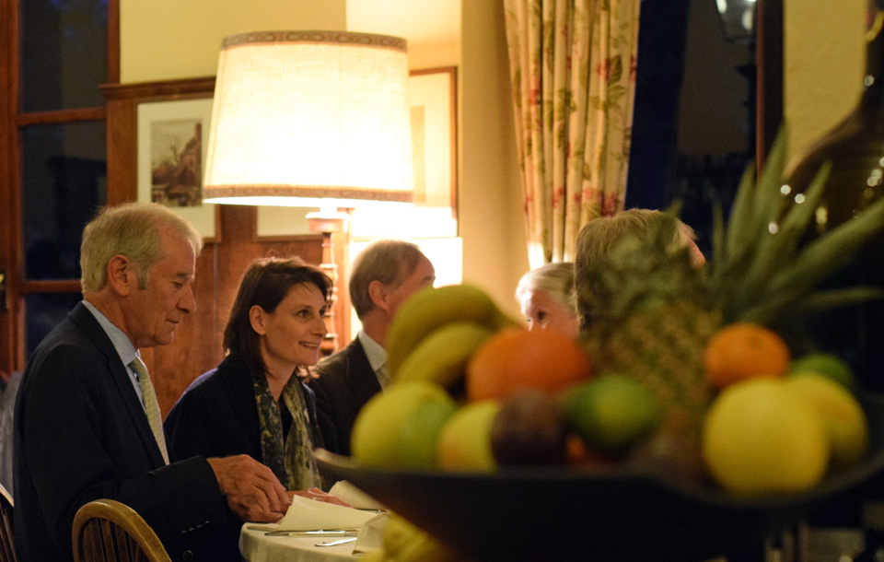
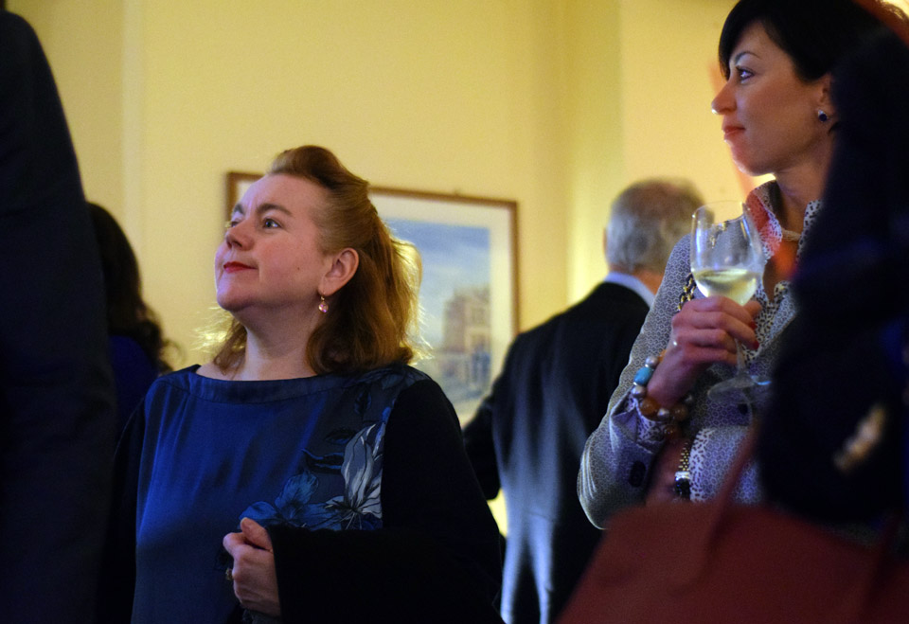
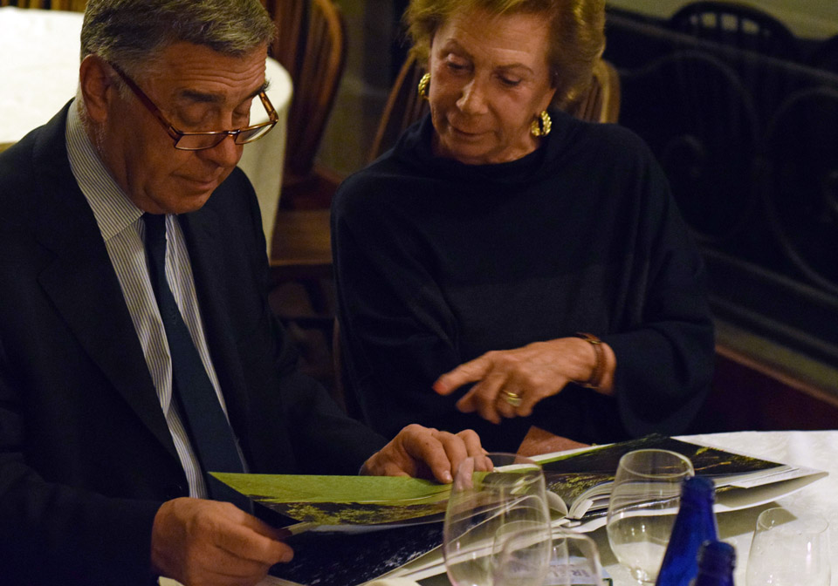
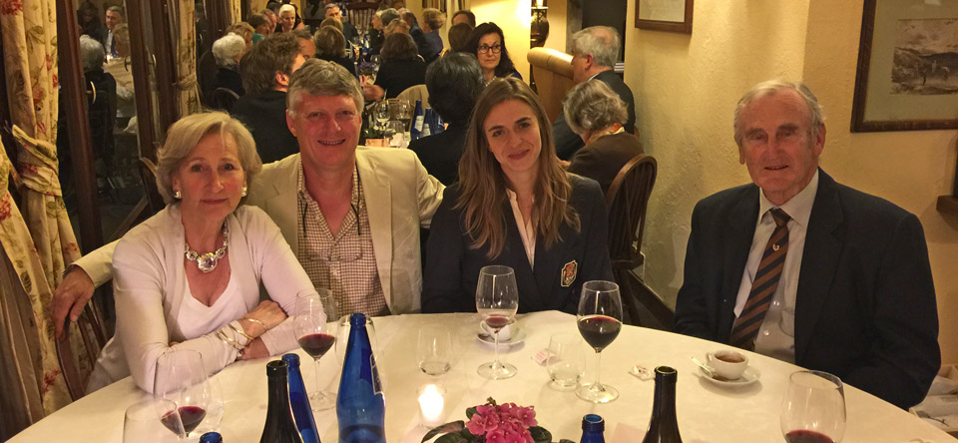
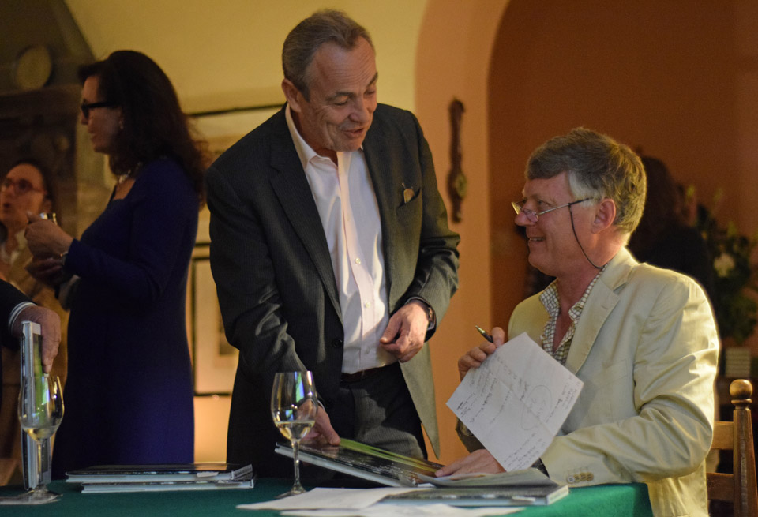
Social

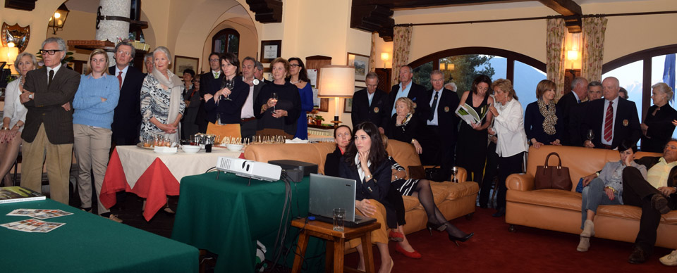
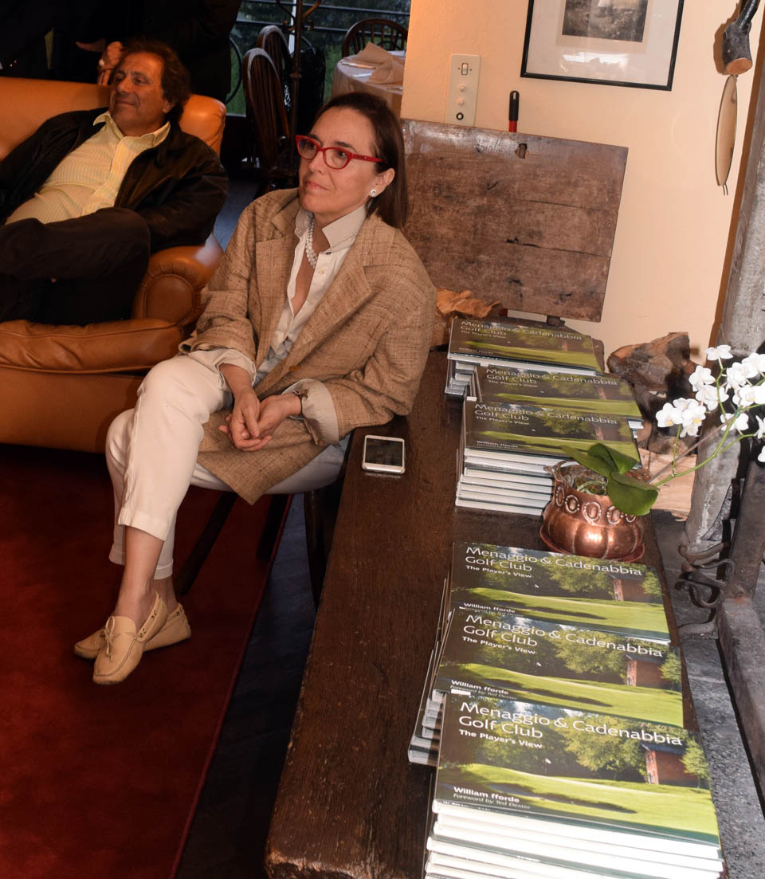
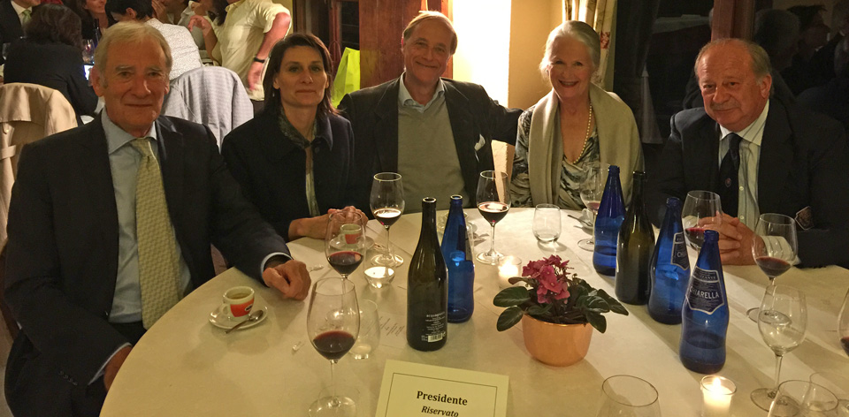
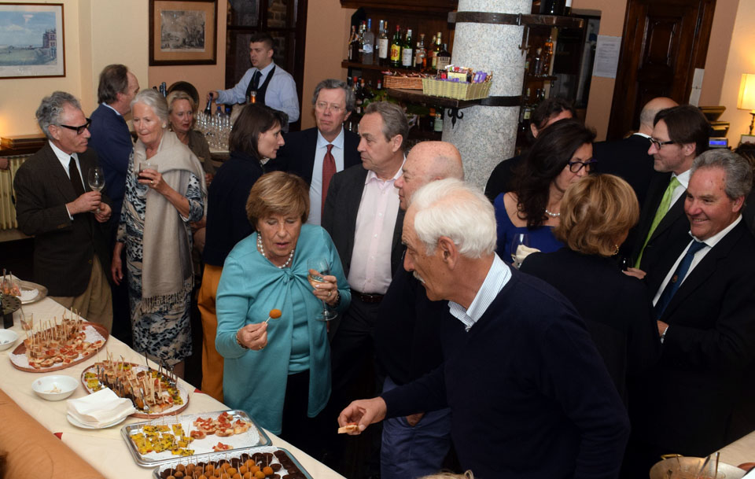
[Ends]

FOR IMMEDIATE RELEASE
Notes for Editors

In addition to the following notes specific to this press release, please refer to the General Notes for Editors, downloadable from the Press page of www.players-view.com

The Player’s View Books

A series of limited edition volumes, which present a feast of photography, showing each hole on the subject golf course as the player might experience it whilst playing a round, accompanied by an informed commentary. This satisfies several objectives:
- to provide club members and visitors with a coffee table opportunity to enjoy the golf course covered;
- to present the course and its design in a way that shows off the talents of its designer through the medium of photography of record, rather than through photography with artistic and/or romantic embellishment;
- to provide a promotional tool for the club - an informative, yet independent commentary on the design and designer of the subject course; in this context it is important to understand that The Player’s View book about a course is not intended as a substitute for, nor to compete with, a club history;

- to assist with the creation, where it all began, of the world’s largest collection of golf course photography through The Hynes Collection at the University of St Andrews, delivering permanent historical documentation for participant courses.
Golf clubs interested in having their courses covered by The Player’s View and/or The Video Guide should contact info@players-view.com.
Details of the two books published to date follow.

The Player’s View: St George’s Hill Golf Club

Commissioned in St George’s Hill’s centenary year through subscription by the club and its members, and written by William fforde (Editor, The Pocket Guide to Golf Courses), The Player’s View: St George’s Hill covers the history of the design of the original two 18 hole courses developed by W G Tarrant and laid out by H S Colt, and describes its post-WW2 conversion into today’s 27 hole complex.
Specification
Title: The Player’s View: St George’s Hill Golf Club
Author: William fforde
Foreword by: Greg Turner
Photographer: William fforde
Publisher: Beckenham Publishing Limited
ISBN 978-0-9548040-3-9
Format Hardback: PPC cover + gloss colour jacket,
114 pages full colour, 3 monochrome and 74 colour photos
22.7 x 30.2 x 1.7 cm
930 gms

The images (which include 27 double page spreads, one for each hole), all taken from the player’s view, are accompanied by a text that recounts the biography of Colt and why St George’s Hill remains such a clear statement of the design philosophy of one of the world’s greatest ever course designers, at the height of his powers.

The book is enhanced by a Foreword from NZ tour-player-turned-course-designer, Greg Turner.

The Player’s View: Menaggio & Cadenabbia GC

Also written by fforde in 2013-14, this book was commissioned by the club and recounts the history of the design of Italy’s second oldest course, which opened 6 years before St George’s Hill, to the design of its founder members (British ex-pats), who famously consulted reigning Open Champion J H Taylor on its original 9 holes, and then again on extension to a full 18 holes.
Specification
Title: The Player’s View: Menaggio & Cadenabbia Golf Club
Author: William fforde
Foreword by: Ted Dexter
Photographer: William fforde
Publisher: Beckenham Publishing Limited
ISBN 978-0-9548040-4-6
Format Hardback: PPC cover + gloss colour jacket,
102 pages full colour, 11 monochrome and 72 colour photos
22.7 x 30.2 x 1.4 cm
890 gms

With its eagles’ nest location above fashionable Lake Como, it is hardly surprising that Menaggio has seen a rich history. Its location and support from owners who included as strong a sporting family as that of Ted Dexter, the former England cricket captain, enabled it to recover strongly from WW2. This led to its purchase in 1960 by the family of Milanese businessman Antonio Roncoroni, who commissioned an extensive redesign by Commander John Harris (contemporaneously dubbed ‘the James Bond’ of golf course design).

Half a century on, Turner, fforde and Scott Macpherson have been engaged by club president Vittorio Roncoroni for an enhancement programme to create a course more challenging to players with 21st century equipment, yet steeped in the club’s history. The re-design will hark back to the early 20th century British design style of Colt, Mackenzie, etc..

In The Player’s View, amidst biblical misquotes, readers are transfigured into God’s ‘clubhouse in the sky’. There, the history of these events unfolds, from the original nine holes to the 21st century masterplan, seen through the eyes of chief protagonists Taylor, Harris and Roncoroni. We meet them in the company of Bernard Darwin (aka ‘San Bernardo’, recently-appointed by St Andrew as patron saint of golf writers). Eavesdropping on the ensuing dialogue, we learn of their parts in the history of the development of the course, and their views on it, including those of the ever-loquacious Bernardo.

The story of how Ted Dexter’s father saw to the course’s restoration after WW2 is presented as extracts from ‘The Book of Ralph’. This anachronism, a hitherto lost book of The Holy Bible, in which even Mussolini scores a footnote, seems to have been phished from heaven following a lapse in St Andrew’s security systems.

The book opens with an intimate foreword from Ted Dexter himself, revealing his family connection with Menaggio GC and the adjoining Villa Lungarna in which he spent much of his childhood.

An added dimension is fforde’s refusal to mention the name of the recently-remarried leading American actor, who is perhaps the most famous member of the club (well…, amongst the living). Instead, 26 film/TV titles credited to The American have been sunk into the text as (to use cricketing parlance) ‘googlies’ for readers to spot and thus reveal his identity. A couple of ‘slower balls’ are also bowled, to confuse the issue – all these deliveries (one of which is repeated in this paragraph) are detailed below, for editors’ convenience.

Biographical notes

Ted Dexter CBE

Born Milan in 1935, Dexter was educated at Radley College and Jesus College, Cambridge at both of which he was captain of cricket. Through this time his family were joint owners of Menaggio GC.

Remaining an ‘amateur’ cricketer throughout his first class and international career (1958-1968): Dexter captained both Sussex and England. An all-rounder, famous for his cavalier and powerful batting style, he completed 9 test match 100s, with a highest test score of 205. He then followed a career as a journalist, sports promotion consultant and cricket administrator, including the presidency of The MCC.

Dexter also played golf to scratch and remains a low handicapper today, continuing to play occasional rounds at Menaggio.

Over the same period, William has written about golf courses in book, magazine and on-line formats. His photographic library, recently donated to the University of St Andrews to launch The Hynes Collection, now covers some 500 courses, across every continent. He has been editor of The Pocket Guide to Golf Courses series, since its foundation in 2001.

Film/TV titles

The following film titles have been sunk into the text of The Player’s View: Menaggio & Cadenabbia GC:

‘Googlies’
(= film/TV titles of the American actor)
#1 out of sight Acknowledgements
#2 from dusk till dawn Acknowledgements
#3 Three Kings Hole 6
#4 the descendants Hole 9
#5 tomorrowland Book of Ralph, Ch XI
#6 confessions of a dangerous mind Hole 14
#7 the Ides of March Hole 14
#8 the harvest Hole 14
#9 up in the air Hole 15
#10 gravity Hole 15
#11 monuments men Hole 16
#12 where[fore] art thou, brother Hole 17
#13 the perfect storm Hole 17
#14 the peacemaker Hole 17
#15 intolerable cruelty Hole 17
#16 waiting for Woody Hole 17

#17 Michael Clayton Hole 17
#18 far from heaven Hole 18
#19 out of sight Hole 18
#20 sand and sorrow Hole 18
#21 the thin red line Hole 18
#22 Er Hole 18
#23 the American Hole 18
#24 oceans Hole 18
#25 burn after reading Hole 19
#26 the book that wrote itself Hole 20

Slower balls
(= film titles inserted in an attempt to dismiss readers)

#1 The Shining Hole 6
#2 [The] Italian Job Hole 16

This information is also available to interested readers on The Player’s View website: www.players-view.com

Contact:

William fforde
Editor, Beckenham Publishing
St Petroc House, Highcliffe, Polzeath, Cornwall PL27 6TN, UK
Tel: +44 (0)161 870 6892 william@players-view.com www.players-view.com

